[1]

Virtual reality in education: benefits and challenges

Jessica Lai

Department of Computer Science

University of Massachusetts

Lowell, MA USA

Jessica_lai@student.uml.edu

***Abstract* – Originally developed to train pilots in the US military in the 1960’s [1], virtual reality (VR) has made much needed advancements, leading to its increase in interest and application. This paper will focus on providing an analysis of the benefits and challenges of using VR for educational purposes.**

# INTRODUCTION

V

R has been used in a variety of different applications to educate and train people. To list some common examples, since the 1960’s, VR has been used to train pilots in the US military [1], first responders of Chemical, biological, radiological and nuclear (CBRN) defenses [2], enhance medical learning in many aspects such as anatomy training [3] and much more. Before the wide spread of head mounted displays (HMD) produced by companies like Facebook, Microsoft, and HTC starting in 2016, VR applications suffered a huge gap between technological capabilities and public expectations for its quality [4]. During that time, VR platforms were costly to implement, lacked in mobility, visual ascetics and much more. recent years.

Since then, many of these difficulties have been resolved. Graphic displays have much better quality of visual displays, and the introduction of HMD made VR cheap and portable. All of these improvements present many opportunities for the field of VR, which has finally gained public interest in the recent years. Today, we are on the forefront of the battlefield, shaping the future of VR field.

Despite the many breakthroughs in VR, the technology is still young and immature since gaining public interest. There still remain many problems for the field to overcome. A major example is the possible health concerns associated with VR, including but not limited to simulator sickness, decrease in vision and losing connection with the physical world [4].

Regardless, different applications of VR are proposed and implemented for various different purposes such as gaming, entertainment, tourism, treating mental anxieties and other sickness, and various educational fields such as medical, engineering, workforce, safely. VR is a great tool because it breaks the scope of limitations. Any situation can be recreated, breaking the limitations and restrictions. Students could train and visit dangerous situations without being exposed to the risk, gain access to expensive equipment they are normally not allowed to touch due to limited resources, share their specific setups and ideas in constant time even when they are on opposite sides of the Earth, and much more. VR holds a huge potential to changing and improving the form of education we currently know and are subjected to. This paperwill cover a breakdown and overview of three major traits of VR with respect to how they can benefit the current educational process. Then we will focus on providing an analysis of the benefits and challenges of using VR for educational purposes.

# Three I’s of VR

Three I’s of VR, more specifically known as immersion, interaction and imagination, is a model to encompass basic traits of VR proposed by Burdea and Coiffet in Virtual Reality Technology [4].

In this model, immersion is the user’s perception of how much they feel as if they are a part of what is taking place inside the virtual environment (VE). This involves replacing the stimulus from the physical world by those of the virtual world to create a false sense of presence and belonging.

Interaction describes how a user is allowed to modify and influence the aspects of the VE using the methods provided to them. In other words, gathering user inputs in the form of voice, gesture, gaze, controllers, etc…, then applying these to change the VE, allowing users to shift from a passive state of observation to an active state of experience.

Imagination involves the design of the VE, more specifically, the lack of limitations in what can exist in the VE and the rules regarding how aspects of the VE may interact with each other. There are infinite possibilities. Anything one can imagine can be recreated in VR for others to experience.

# Immersion

With the rapid innovations in technology, humans have adapted to learn in new ways. Reading textbook with dry content or attending lectures are often boring for students, causing them to have less motivation to participate, much less learn when using such methods. Students instead choose to use other resources, such as tutorial videos and applications that make studying game based which are less taxing and raise their motivation. As research as shown, immersion can have a huge impact on the motivation for games based learning, which is already much higher than motivation resulting from traditional teaching methods. Students were more motivated to pay attention to the content and obtained more confidence using the VR biology game as opposed to a non-immersive biology game [5]. The students also indicated a preference to learn using VR [5].

VR can also be helpful for online classes, which experience an exceedingly low completion rate of 5% [6]. Although online classes provide discussion groups, the majority of the interaction lays in completing assignments and quizzes assigned by referencing premade course material. Studies have shown that this lack of community results in lesser sense of commitment and motivation to complete the course [6]. The use of VR can improve motivation for students at least to browse through the content which most students do not do [6]. The immersive experience can also keep students fully connected and engaged in the content.

# Interaction

Most people learn better visually and are able retain their learning’s for a longer time if they are able to repetitively associate the knowledge with a relevant experience. There are two key aspects to this: the ability to react to the environment and the ability to repeat the process. The ability to react to the environment points to the different forms of user interaction VR allows.

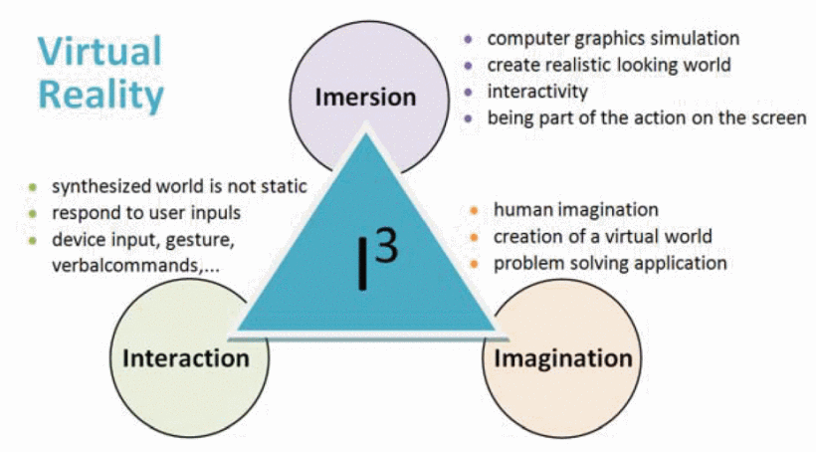

Fig. 1. Three I’s of virtual reality

A VR fire safely application build and tested combined interaction aspects of knowledge learning through multiple-choice problems and practice through ways such as using virtual fire extinguishers because different types of interactions have to be appropriately chosen so the knowledge can be easily transferred for use in real life [7]. The experience of using a fire extinguisher, even if it is only virtual, could not be taught in a textbook. Results of three test groups, immersive VR, non-immersive VR, and textbook showed that groups using VR were able to more learn knowledge and the group using immersive VR were able to better operate a fire extinguisher. The options for interaction that VR opens up can allow for interactive ways to learn knowledge that are more transferable to actual use.

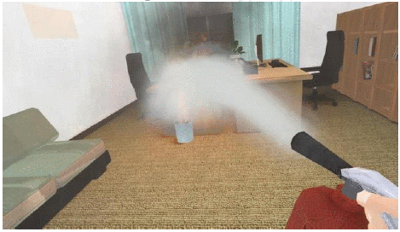

Fig. 2. Operating virtual fire extinguisher

# Imagination

The lack of limitation in the creation of the VE could be said to be the most beneficial aspect of VR. Returning to the second key aspect of retaining knowledge, the ability to repeat the process, can be achieved by VR precisely due to its ability to re-create anything with no cost after the scene is initially fabricated. This is a great way to allow students to be able to practice for expensive material and equipment without the financial burden. This can also allow for practice in situations that are not easily replicated or could not be created at all in the case of the fire training.

The ease of recreation also allows for ease in sharing without limitation to distance and cost of replication with absolute accuracy. This can also be adapted to create a sense of community. Extending this back to the example of online classes, extending the VE can be used to build new ways of interact with members in the class to increase the presence of a community. If the VE was designed to record the presence of all students who looked at a particular module and each user is able leave questions with a virtual avatar that students and teacher who view the module after is able to see and answer, it could greatly increase the presence of community and companionship. By visualizing classmates and the teacher, the VE effectively makes them a “real” part of the class to the user.

# Benefits of VR in Education

There are vase benefits to using VR for education. Its element of immersion increases motivation and attention of students on the topic. The wide scope of interaction allowed for by the VE offers more choices in the ways to convey the knowledge in the most transferable way. The game flow can also be optimized using the user input, offering instant feedback with appropriate warning and support during the process. The freedom in the creation of the VE allows VR to restore and extend beyond reality, breaking the scope of limitations. High cost labs facilities can be recreated for practice without fear of breaking expensive machines due to simple errors. Dangerous situations could be simulated without exposure to risk. Specific setups and ideas could easily be shared and recreated at no extra cost. Best of all, the cost to operate and maintain such systems are negligible save for the money for the equipment and the initial time and cost to make the simulation. This could also cut down cost to hire staff due to the general self-teaching process and intuitive learning process.

# Challenges of VR in Education

Potential health concerns associated with VR still stands as a barrier to the wide spread use of VR in educational settings. Simulator sickness, decrease in vision and losing connection with the physical world [4] are all concerning ethical issues if VR learning was put into full use. Hardware limitations on user input in cheaper, mobile operated HMD options such as Google Cardboard also limits the benefits of VR in terms of the interaction perspective. Higher end devices such as the Oculus Rift is still too expensive to be put to general use in school settings especially since it would also have to be paired with an expensive personal computer (PC).

# Conclusion

VR has been and will continue to be used to improve the quality of education. Since the VR boom in 2016, the interest in the field has grown even more. In today’s world, we are able to achieve the seemingly impossible with VR.

Compared to traditional learning methods, VR is able to motivate students and retain their attention. VR allows knowledge to be delivered in the most transferable format to real life tasks and provides instant feedback to each individual user. VR can replicate and extend beyond reality, easily allowing any situation to be created, even rare or dangerous situations. There is no cost to recreate previously created VE in VR, allowing repetition of tasks to reinforce learning and easy sharing of setups and idea. Lastly, VR is able to reduce cost of education in many ways.

There are still challenges to face before VR could be wide spread in educational facilities. The most concerning is the potential health concerns of VR usage. The hardware limitations on low-end devices also cause potential concern in the cost of investment.

This paperwe have broken down the three major traits of VR and how they can benefit the current educational process. We also discussed the benefits and concerns of using VR for educational purposes. Despite these challenges, the gradual integration of VR to enhance traditional education will most likely occur in the near future.

References

1. L. Ying, Z. Jiong, S. Wei, W. Jingchun and G. Xiaopeng, "VREX: Virtual reality education expansion could help to improve the class experience (VREX platform and community for VR based education)," 2017 IEEE Frontiers in Education Conference (FIE), Indianapolis, IN, USA, 2017, pp. 1-5.
2. D. W. Carruth, "Virtual reality for education and workforce training," 2017 15th International Conference on Emerging eLearning Technologies and Applications (ICETA), Stary Smokovec, 2017, pp. 1-6.
3. J. Falah et al., "Virtual Reality medical training system for anatomy education," 2014 Science and Information Conference, London, 2014, pp. 752-758.
4. L. Stuchlíková, A. Kósa, P. Benko and P. Juhász, "Virtual reality vs. reality in engineering education," 2017 15th International Conference on Emerging eLearning Technologies and Applications (ICETA), Stary Smokovec, 2017, pp. 1-6.
5. T. d. S. Silva, E. C. R. Marinho, G. R. E. Cabral and K. S. d. Gama, "Motivational Impact of Virtual Reality on Game-Based Learning: Comparative Study of Immersive and Non-Immersive Approaches," 2017 19th Symposium on Virtual and Augmented Reality (SVR), Curitiba, 2017, pp. 155-158.
6. D. Cortiz and J. O. Silva, "Web and virtual reality as platforms to improve online education experiences," 2017 10th International Conference on Human System Interactions (HSI), Ulsan, 2017, pp. 83-87.
7. X. Pan, Z. Zhang, J. Qu, C. Zhao and Y. Li, "Enjoy driving from thought in a virtual city," 2017 36th Chinese Control Conference (CCC), Dalian, 2017, pp. 11034-11040.
8. K. Zhang, J. Suo, J. Chen, X. Liu and L. Gao, "Design and implementation of fire safety education system on campus based on virtual reality technology," 2017 Federated Conference on Computer Science and Information Systems (FedCSIS), Prague, 2017, pp. 1297-1300.

1.